Module 4 Portfolio Milestone

Nathan Rogers
Colorado State University Global
Course Code: CSC506
Professor Farr
05/11/2025

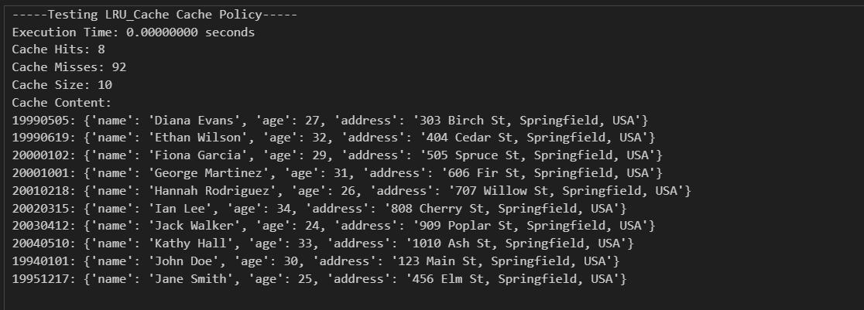

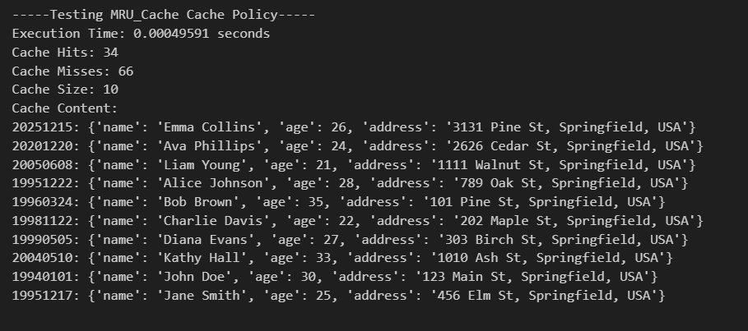

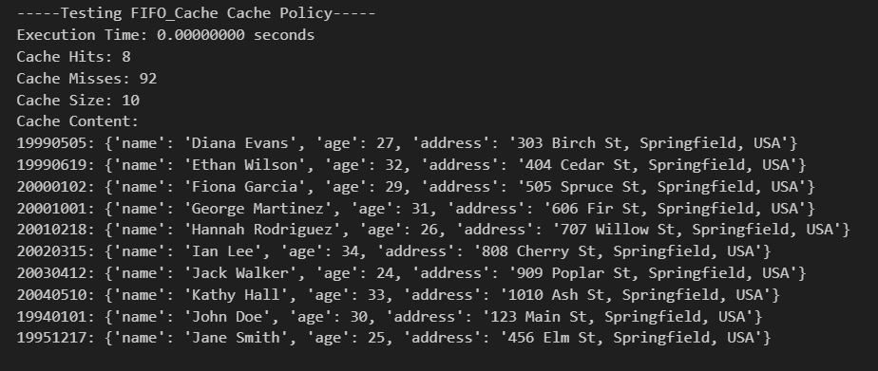

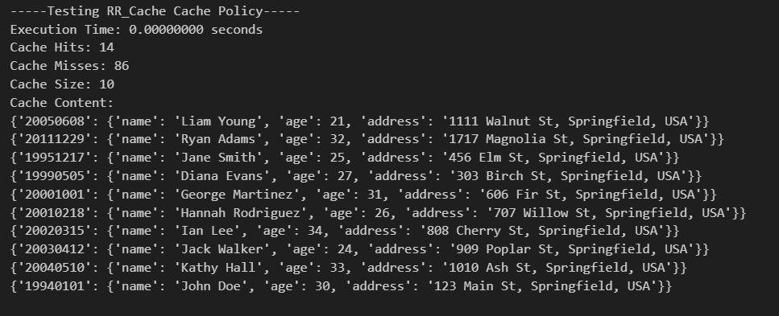

Introduction
“Caching is a system design concept that involves storing frequently accessed data in a location that is easily and quickly accessible.” (Caching - system design concept 2024). The purpose of this project is to become more familiar with implementing and understanding different cache replacement policies within a Cache Simulator. There are four replacement policies included in this simulator: LRU (Least Recently Used), MRU (Most Recently Used), FIFO (First In First Out), and RR (Random Replacement). “Caches have a limited capacity, though, and the system must choose which data to delete when the cache is full. The cache eviction policies provide the criteria for choosing which data to replace.” (Cache eviction policies: System design 2024). Within this simulator, the hit and miss rate will be evaluated and compared across each replacement policy.
Design and Implementation Process
I started designing my program by implementing one Cache class with each replacement policy being a class functions so they would have access to class variables such as size and hits and misses. This, however, implementation posed a few issues. I would need a hit and miss class variable to keep track of each policy but also a separate cache object for each policy. This was the point I realized I needed a separate class per replacement policy to reduce cluttering one singular class up. Having a class object per replacement policy allows for an easier-to-read program along with their own separate variables. Each class replacement policy could then have its own put, evict and print_statistics function.
For each cache I initially believed that a regular dictionary would be sufficient, however, I realized that order for three out of four replacement policies depended on the data being ordered in the way that the data was added. This meant I had to turn to use the OrderedDict object. As a bonus, the popitem function within the OrderedDict object allows for removal of the first or last item. If a regular dictionary was to be utilized in this case, then the new walrus operator in a list-comprehension style would have to be used to pop the first item from the object.
Implementing each replacement policy was straightforward and really solidified my understanding of each replacement policy. LRU and FIFO were very similar to where each time the cache became full, on a miss it would remove the first element and MRU is the opposite of LRU where the most recent item is removed. RR was very different as a random element needed to be evicted each time the cache became full. Here I decided to utilize a list rather than a type of dictionary to make the random selection and removal easier. Attempting to utilize random numbers and dictionaries would include an additional for-loop to iterate through until that index is found and then removed. Using a list simplified that process and allowed direct access of that index for removal.
The piece that I really struggled with was choosing how to evaluate all replacement policies at once using the same data during each iteration and renewing the test data between iterations. My initial attempts included an array in which I hand-filled each element, trying to keep in mind to include repeat data to test hits, new data to test misses, and sequence them in a way that both can be simulated. This became tedious as each time I wanted new data I had to repeat this process repeatedly. I settled upon a generation loop to where the global data set was linearly added to a test list and then randomly the linear iteration would reset to include repeat data. A variable was set for the max size so that the dataset could easily be increased or decreased from test to test. This test set could then be used to test each eviction/replacement policy without bias towards one policy or another.
Data Analysis
Upon running the eviction/replacement policies on the randomly selected data, it can be observed that LRU and FIFO had the same results despite LRU moving the hit item to the end of the list before eviction of the first item. MRU appears to have the highest and most consistent hit rate with RR not too far behind. This is interesting due to modern CPUs utilizing LRU replacement policies. This begs the question, is there a better way to simulate data put and eviction that random data selection isn’t testing? Perhaps cache size influences hit and miss rate with a small cache size having a negative effect over a larger cache size.

References
CSC506: Design and Analysis of Algorithms home | zyBooks. Zybooks. (n.d.). https://learn.zybooks.com/zybook/CSC506-1_10
Cache eviction policies: System design. GeeksforGeeks. (2024, October 29). https://www.geeksforgeeks.org/cache-eviction-policies-system-design/
Caching - system design concept. GeeksforGeeks. (2024b, December 20). https://request.geeksforgeeks.org/?p=468000

